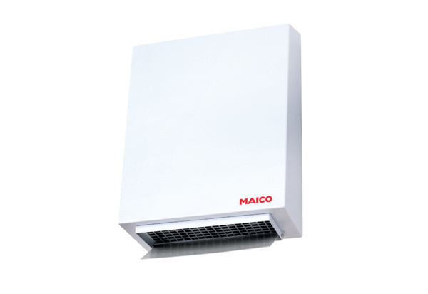Centrifugal external wall fan AWV 12 ECPacking unit: 1 pieceRange: E
Article number: 0073.0574Manufacturer: MAICO

