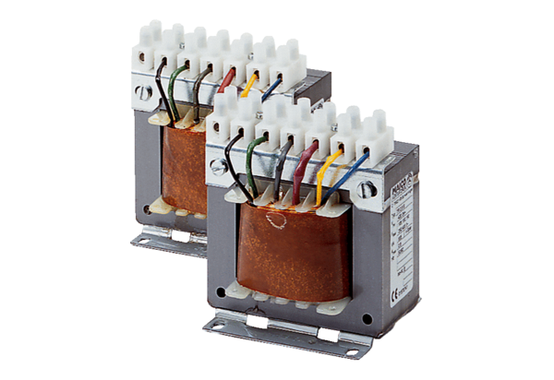5-step transformer, control cabinet TR 6,6 SPacking unit: 1 pieceRange: C
Article number: 0157.0743Manufacturer: MAICO

