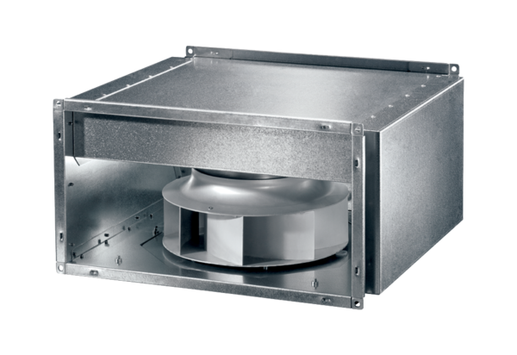Sound-insulated channel fan DSK 35 ECPacking unit: 1 pieceRange: E
Article number: 0086.0807Manufacturer: MAICO

