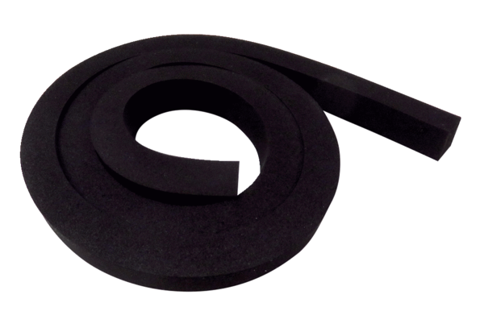Sealing DI WS 75Range: K
Article number: E192.0801.0000Manufacturer: MAICO

