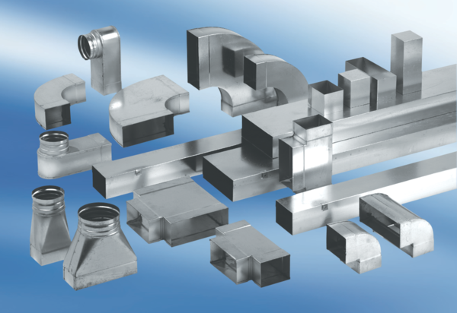90° angle elbow, extended, symmetrical WB90V/55/110/125Packing unit: 1 pieceRange: K
Article number: 0055.0749Manufacturer: MAICO

