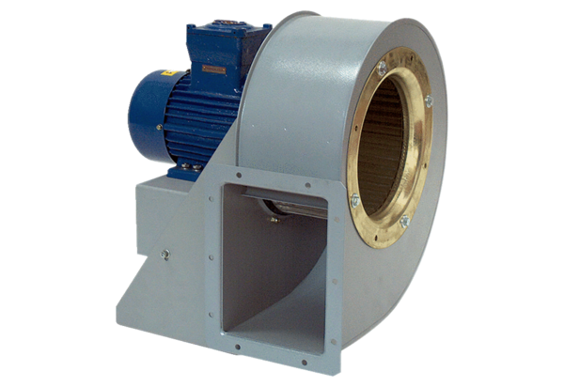Centrifugal blower GRM HD 40/6 ExPacking unit: 1 pieceRange: C
Article number: 0073.0415Manufacturer: MAICO

