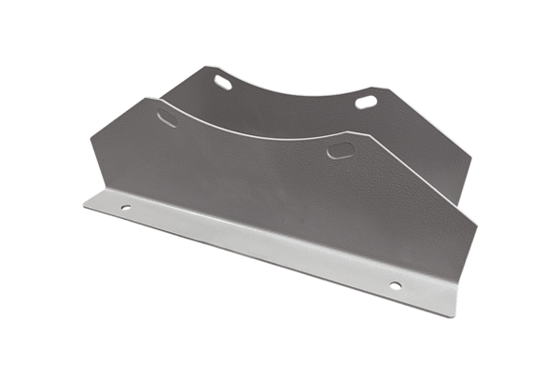Mounting foot FUI 140Packing unit: 1 pieceRange: C
Article number: 0073.0232Manufacturer: MAICO

