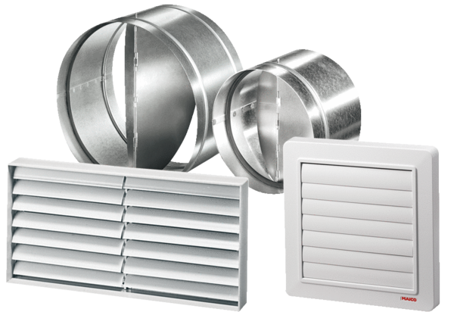Channel shutter RKP 25Packing unit: 1 pieceRange: D
Article number: 0151.0236Manufacturer: MAICO

