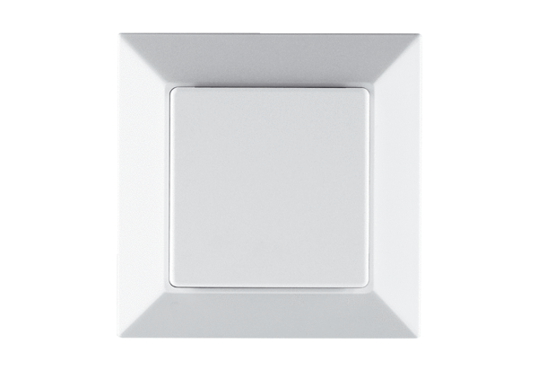EnOcean extension module PP 45 EOPacking unit: 1 pieceRange: K
Article number: 0157.0362Manufacturer: MAICO

