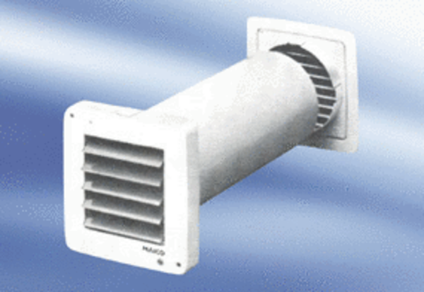Small room fan ECA 9-5Packing unit: 1 pieceRange:
Article number: 080030Manufacturer: MAICO

