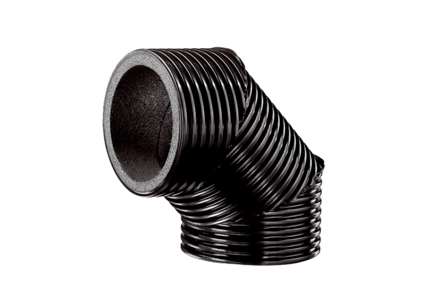Ventilation elbow, thermally insulated MT-B160 90/45Packing unit: 1 pieceRange: K
Article number: 0059.0984Manufacturer: MAICO

