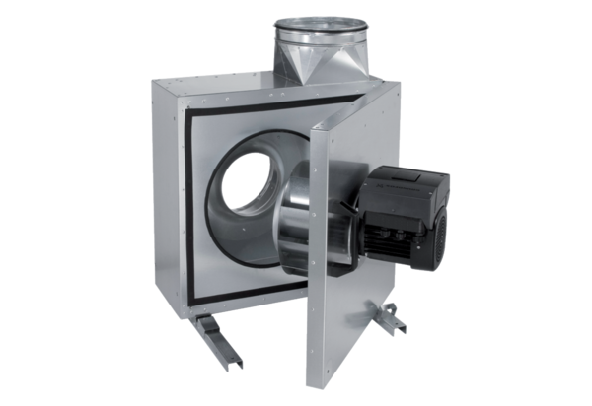Sound-insulated ventilation box EKR 40 FUPacking unit: 1 pieceRange: E
Article number: 0080.0898Manufacturer: MAICO

