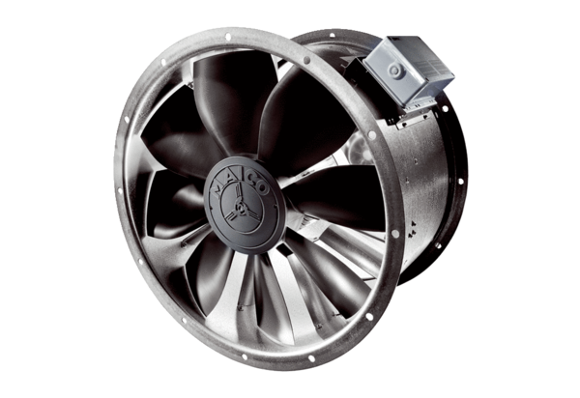Axial duct fan DZL 60/84 BPacking unit: 1 pieceRange: C
Article number: 0086.0100Manufacturer: MAICO

