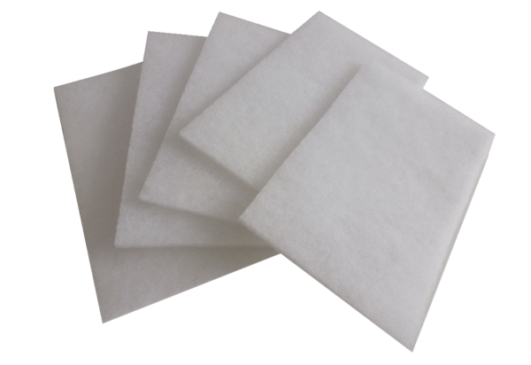Air filter, replacement FF 10Packing unit: 5 piecesRange: B
Article number: 0093.0377Manufacturer: MAICO

