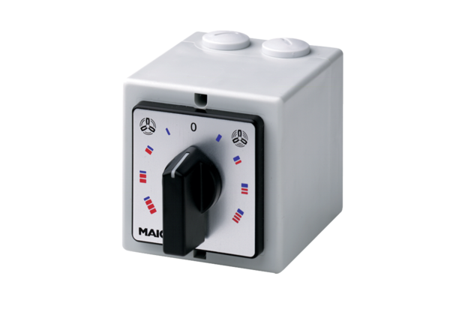HP 1Packing unit: 1 pieceRange: C
Article number: 0157.0463Manufacturer: MAICO

