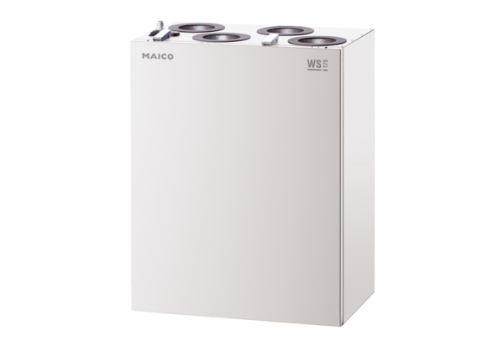Centralised ventilation unit WS 170 KBLETPacking unit: 1 pieceRange: K
Article number: 0095.0115Manufacturer: MAICO

