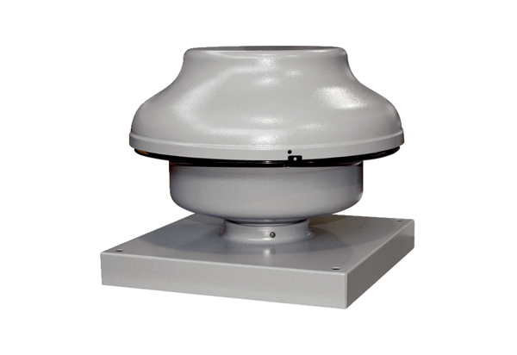Centrifugal roof fan EHD 10Packing unit: 1 pieceRange: C
Article number: 0087.0300Manufacturer: MAICO

