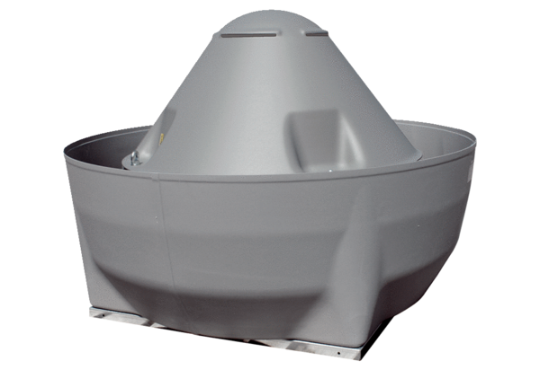Centrifugal roof fan DRD V 75/6Packing unit: 1 pieceRange: C
Article number: 0073.0071Manufacturer: MAICO

