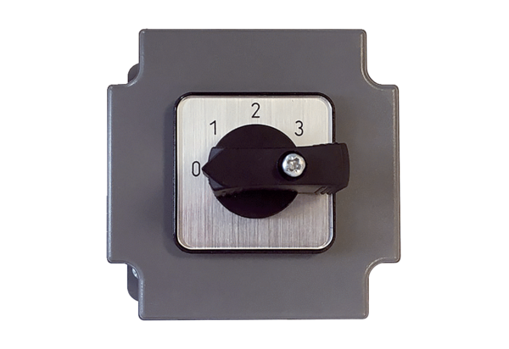3-step switch DS 3 ECPacking unit: 1 pieceRange: E
Article number: 0157.0187Manufacturer: MAICO

