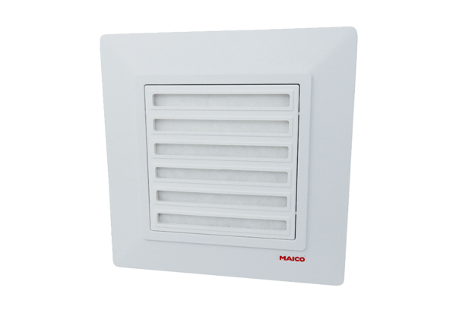Cover ABD ER 17 1Range: B
Article number: E093.0570.0002Manufacturer: MAICO

