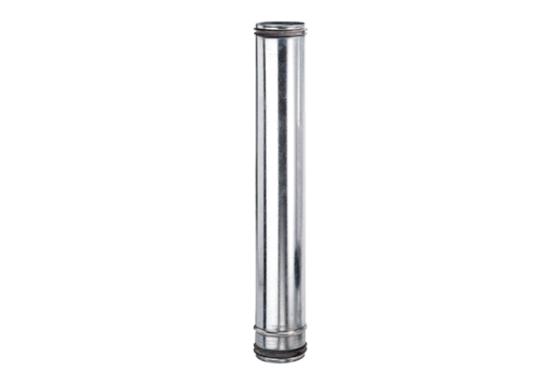Fire protection compensation element BA 100-0Packing unit: 1 pieceRange: B
Article number: 0093.1019Manufacturer: MAICO

