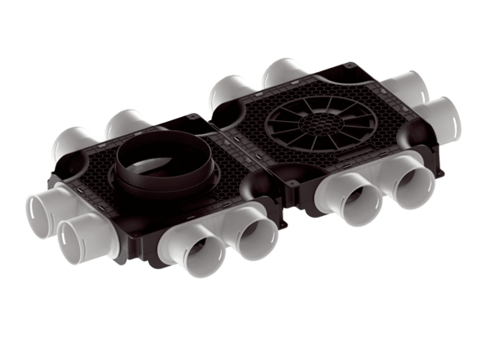Flat and compact double air distributor, made of plastic, 12-way MA-FDV12-75Packing unit: 1 pieceRange: K
Article number: 0059.2128Manufacturer: MAICO

