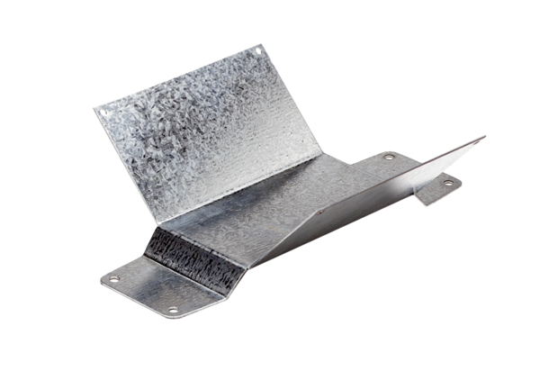Mounting foot FUM 22Packing unit: 1 pieceRange: C
Article number: 0036.0004Manufacturer: MAICO

