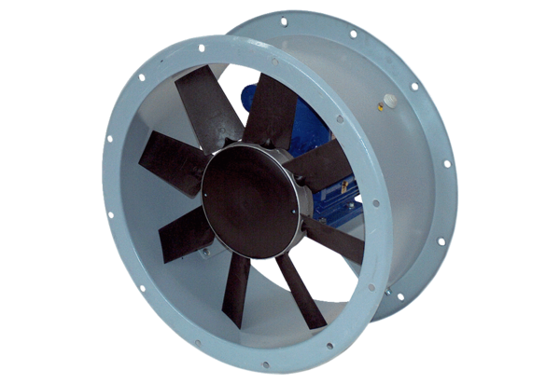Axial duct fan DAR 80/4 5,5Packing unit: 1 pieceRange: C
Article number: 0073.0142Manufacturer: MAICO

