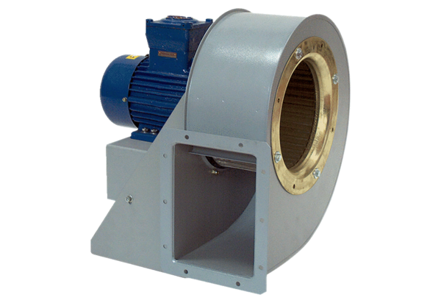Centrifugal blower GRM HD 45/6 ExPacking unit: 1 pieceRange: C
Article number: 0073.0418Manufacturer: MAICO

