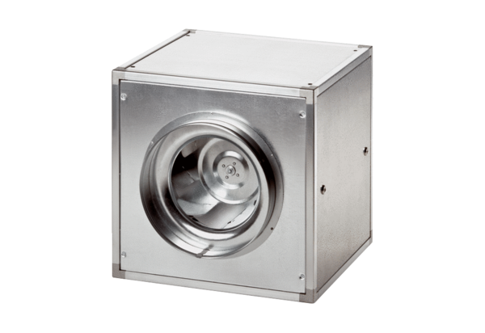Quickbox DSQ 50/4Packing unit: 1 pieceRange: C
Article number: 0080.0038Manufacturer: MAICO

