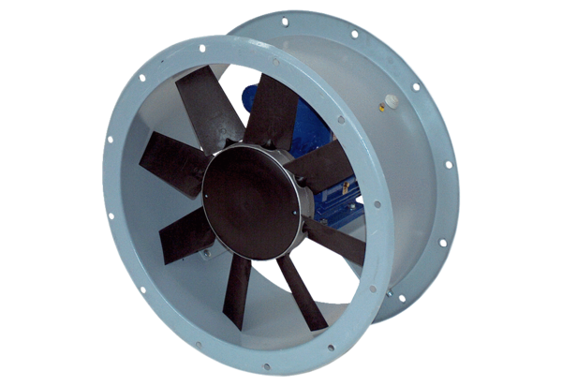Axial duct fan DAR 100/6 1,1Packing unit: 1 pieceRange: C
Article number: 0073.0172Manufacturer: MAICO

