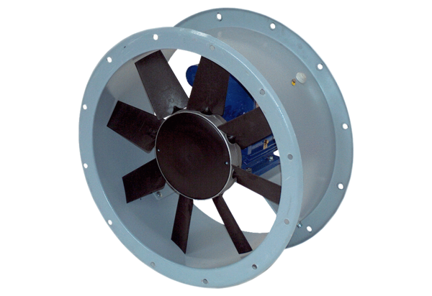Axial duct fan DAR 80/8-3 ExPacking unit: 1 pieceRange: C
Article number: 0073.0362Manufacturer: MAICO

