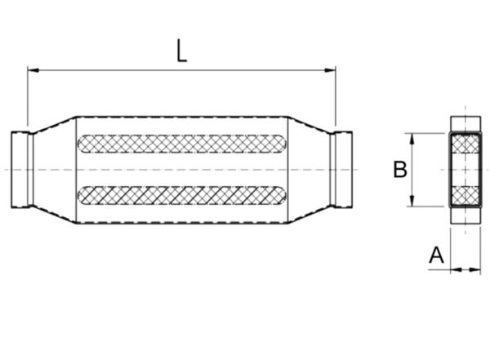40 mm channel sound absorbers with attenuating linging. KSD55/110/700Packing unit: 1 pieceRange: K
Article number: 0092.0452Manufacturer: MAICO

