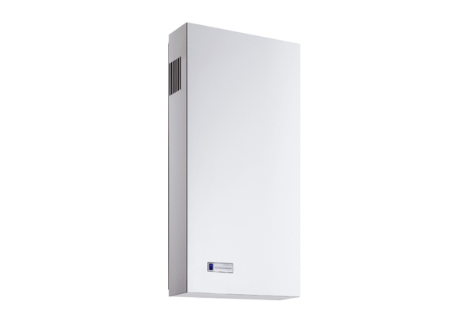installation kit Duo AO-SEPacking unit: 2 x G3Range: K
Article number: 0095.0560Manufacturer: MAICO

