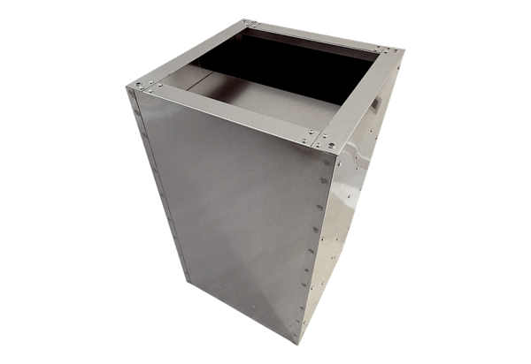Socket sound absorber SDVI 63-75Packing unit: 1 pieceRange: C
Article number: 0073.0039Manufacturer: MAICO

