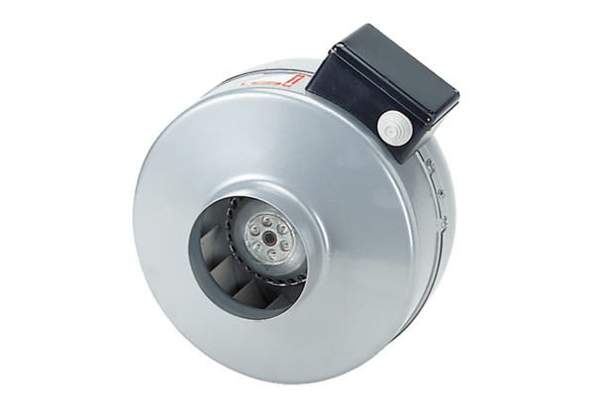Centrifugal duct fan ERR 12/1 NPacking unit: 1 pieceRange: E
Article number: 0080.0866Manufacturer: MAICO

