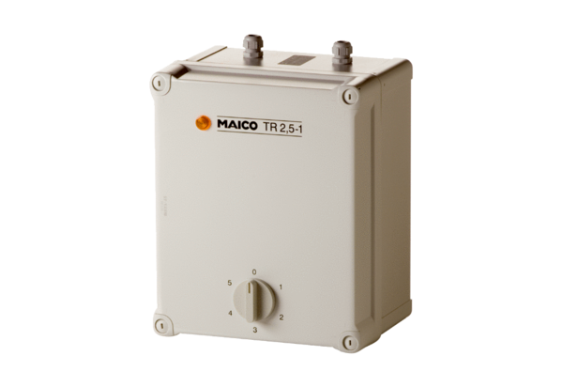5-step transformer TR 2,5-1Packing unit: 1 pieceRange: C
Article number: 0157.0372Manufacturer: MAICO

