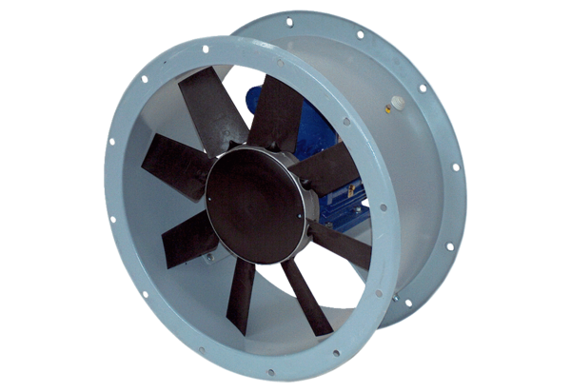Axial duct fan DAR 125/6 11Packing unit: 1 pieceRange: C
Article number: 0073.0188Manufacturer: MAICO

