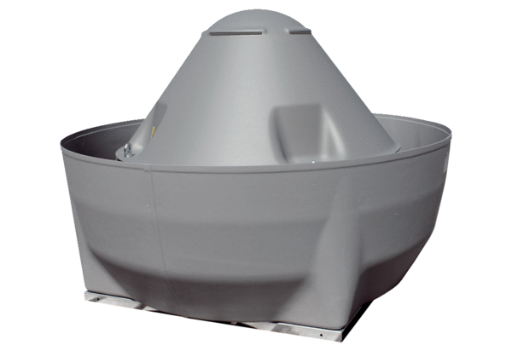Centrifugal roof fan DRD V 75/6 ExPacking unit: 1 pieceRange: C
Article number: 0073.0553Manufacturer: MAICO

