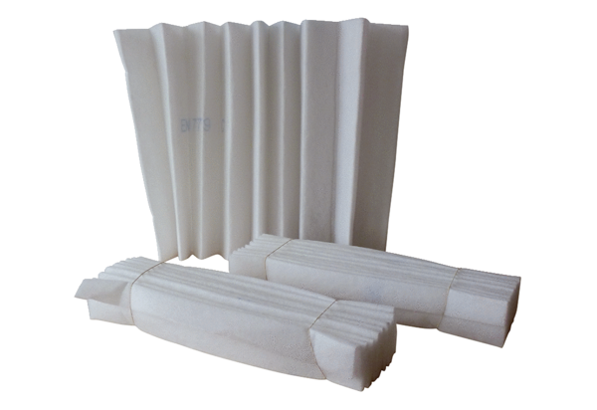Air filter, replacement FF 40Packing unit: 3 piecesRange: C
Article number: 0093.0234Manufacturer: MAICO

