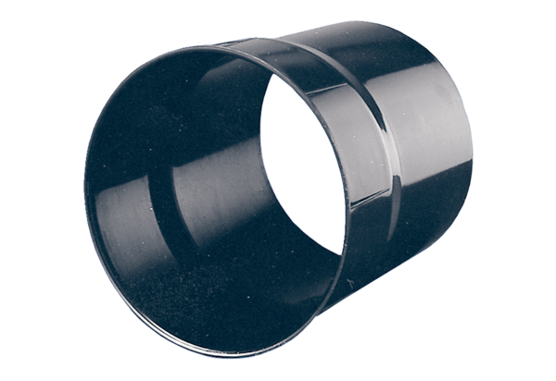Wall sleeve WH 25Packing unit: 1 pieceRange: C
Article number: 0059.0230Manufacturer: MAICO

