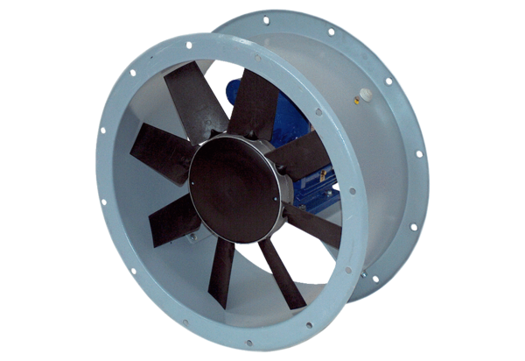Axial duct fan DAR 90/6-2 ExPacking unit: 1 pieceRange: C
Article number: 0073.0367Manufacturer: MAICO

