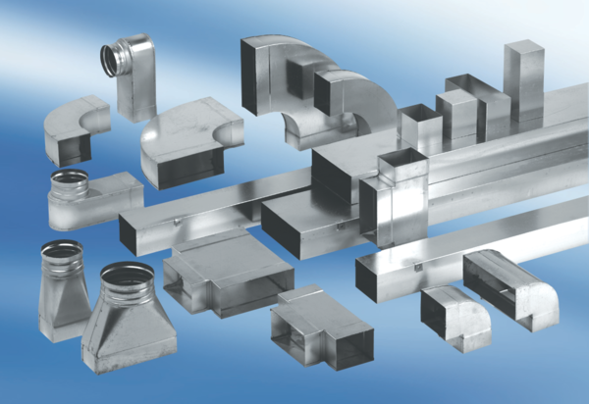Reducer, symmetrical REDS80/200/55Packing unit: 1 pieceRange: K
Article number: 0055.0705Manufacturer: MAICO

