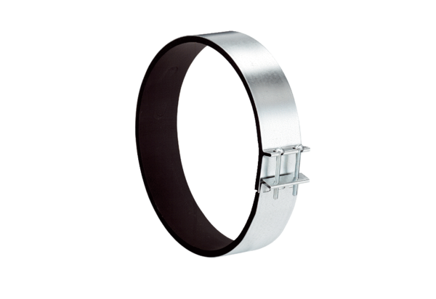Fixing cuff ELR 40Packing unit: 1 pieceRange: C
Article number: 0092.0116Manufacturer: MAICO

