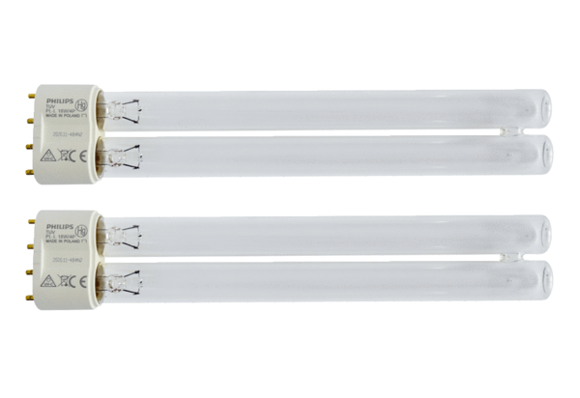UV-C lamps CB 300 UV-CPacking unit: 2 piecesRange: L
Article number: 0092.0584Manufacturer: MAICO

