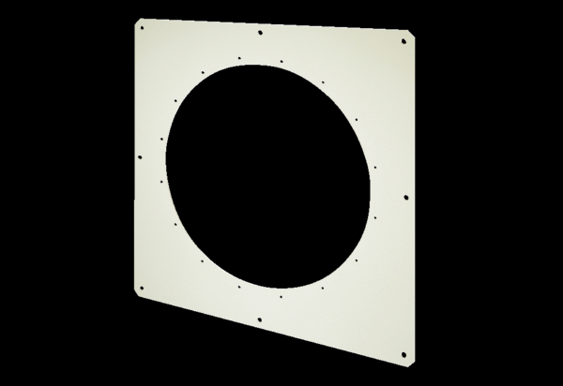Square wall plate QW 90Packing unit: 1 pieceRange: C
Article number: 0053.0015Manufacturer: MAICO

