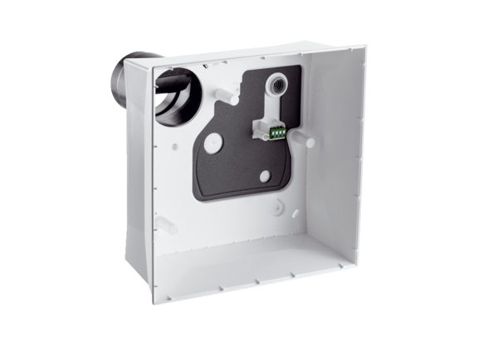Surface-mounted housing ER GH APPacking unit: 1 pieceRange: B
Article number: 0084.0352Manufacturer: MAICO

