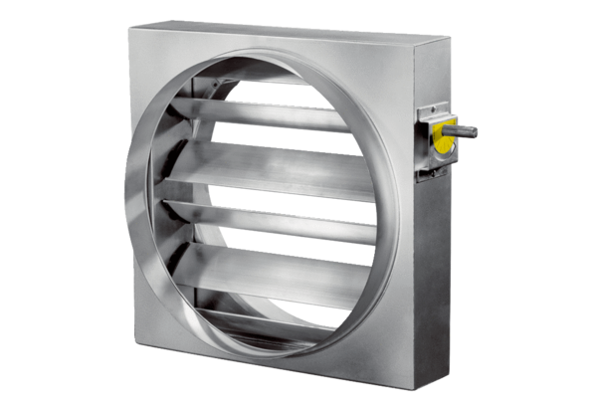Control shutter JRE 60Packing unit: 1 pieceRange: C
Article number: 0151.0395Manufacturer: MAICO

