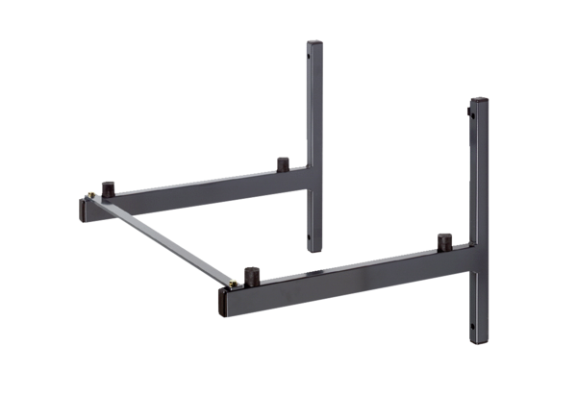Wall bracket WSK 250Packing unit: 1 pieceRange: K
Article number: 0018.0223Manufacturer: MAICO

