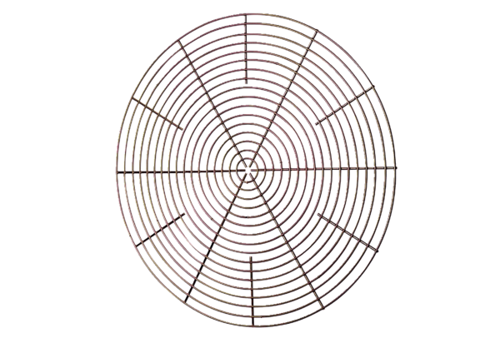Protective grille, metal SG 50Packing unit: 1 pieceRange: C
Article number: 0150.0120Manufacturer: MAICO

