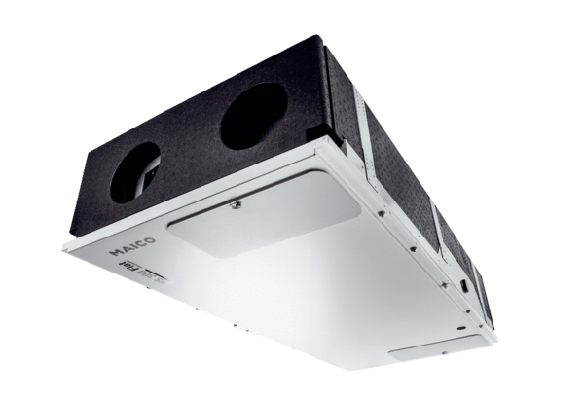Centralised ventilation unit WS 300 Flat LPacking unit: 1 pieceRange: K
Article number: 0095.0141Manufacturer: MAICO

