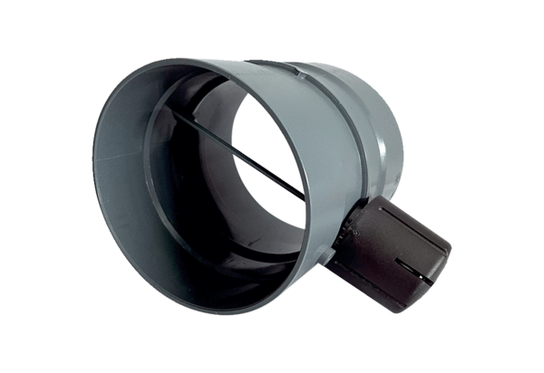Manual throttle valve MDKI 28Packing unit: 1 pieceRange: C
Article number: 0073.0482Manufacturer: MAICO

