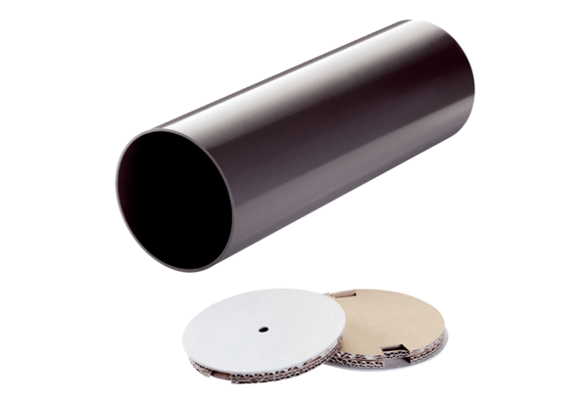Shell sleeve PP 45 RHLPacking unit: 1 pieceRange: K
Article number: 0059.0082Manufacturer: MAICO

