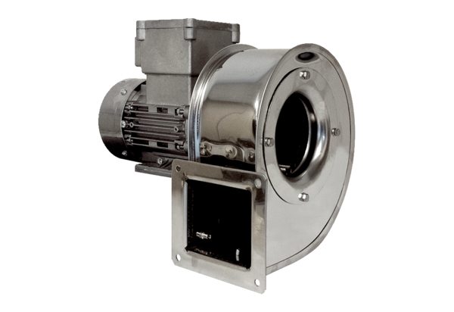Centrifugal blower GRM ES 18/2 ExPacking unit: 1 pieceRange: C
Article number: 0073.0395Manufacturer: MAICO

